Lab – 6 - 210905019 – Viraj Chetan Desai
1. Switching Cisco IOS Command Modes
This exercise demonstrates how to log into a router and how to work with the different Cisco
IOS command modes. It is important to understand the different modes so you know where you
are and what commands are accepted at any time.
i. Connect the Ethernet interfaces of the Linux PCs and the Cisco router as shown in Figure 6.7.
Do not turn on the Linux PCs yet.
ii. Right-click on Router1 and choose Start.
iii. Right-click on Router1 and choose Console. Wait a few seconds until the router is initialized.
If everything is fine, you should see the prompt shown below. This is the User EXEC mode. If
the prompt does not appear, try to restart GNS3 and repeat the setup again.

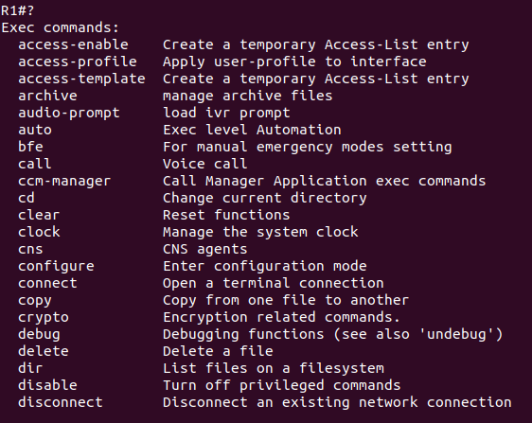
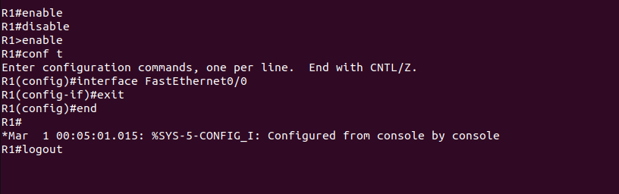
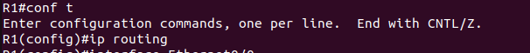
2)The following exercises use basic commands from the Cisco IOS that are needed to configure a
Cisco router.
i. Right-click on Router1 and choose Start.
ii. Right-click on Router1 and choose Console. Wait some seconds until the initial console
window is set up. When the router is ready to receive commands, proceed to the next step.
iii. Configure Router1 and Router 2 with the IP addresses given in Figure 6.7.
In Router 1
Interface Fastethernet0/0 in global configuration mode
R1(config)#inter f 0/0
R1(config-if)#ip address 10.0.0.1 255.0.0.0
R1(config-if)#no shutdown
R1(config-if)#exit
Interface Serial 2/0
R1(config)#inter s2/0
R1(config-if)#ip address 20.0.0.1 255.0.0.0
R1(config-if)#clock rate 64000
R1(config-if)#encapsulation ppp
R1(config-if)#no shutdown
R1(config-if)#exit
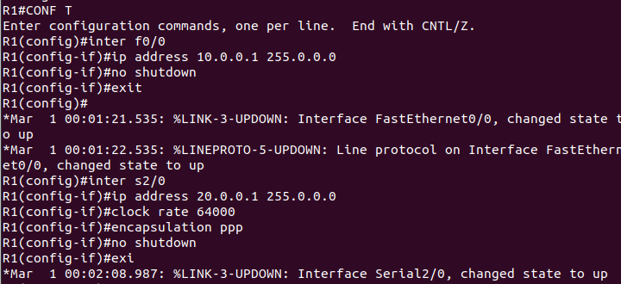

Interface Fastethernet 0/0
R2(config)#inter f0/0
R2(config-if)#ip address 30.0.0.1 255.0.0.0
R2(config-if)#no shutdown
R2(config-if)#exit
Interface Serial 2/0
R2(config)#inter s2/0
R2(config-if)#ip address 20.0.0.2 255.0.0.0
R2(config-if)#encapsulation ppp
R2(config-if)#no shutdown
R2(config-if)#exit

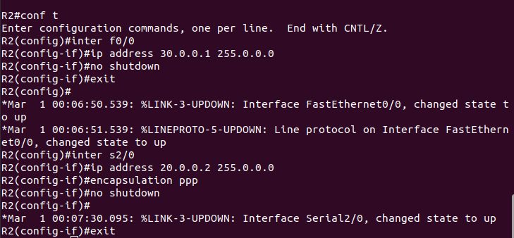
iv. When you are done, use the following command to check the changes you made to the router
configuration, and save the outputs:
R1# show interfaces
R1#show running-config

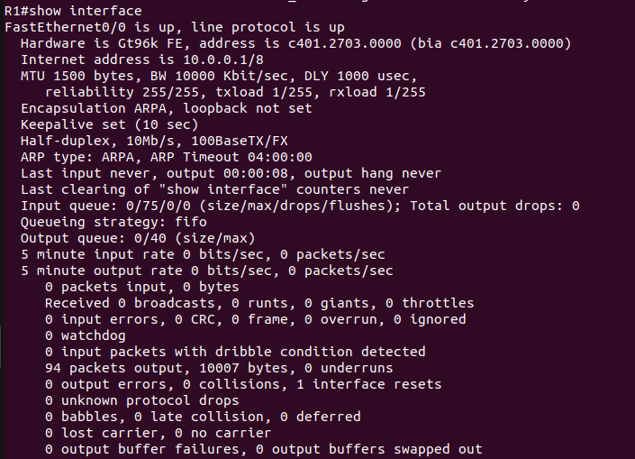
R1#show running-config
Building configuration...

Current configuration : 1495 bytes
!
version 12.4
service timestamps debug datetime msec
service timestamps log datetime msec
no service password-encryption
!
hostname R1
!
boot-start-marker
boot-end-marker
!
!
no aaa new-model
memory-size iomem 5
no ip icmp rate-limit unreachable
ip cef
!
!
!
!
no ip domain lookup
ip auth-proxy max-nodata-conns 3
ip admission max-nodata-conns 3
!
!
!
!
!
!
!
!
!
!
!
!
!
!
!
!
!
ip tcp synwait-time 5
!
!
!
!
!
interface FastEthernet0/0
ip address 10.0.0.1 255.0.0.0
duplex auto
speed auto
!

v. Assign ip addresses for both PC's as mentioned in Figure 6.7 with appropriate ip and subnet
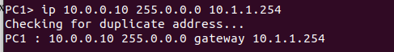
maskand default gateway.

3)Setting static routing table entries on a Cisco router
In this exercise, you will add static routes to the routing table of Router1. The routing table must
be configured so that it conforms to the network topology shown in Figure 6.7. The routes are
configured manually, which is also referred to as static routing.
The IOS command to configure static routing is ip route. The command can be used to show,
clear, add, or delete entries in the routing table. The commands are summarized in the list below.

R1(config)#ip route Destination Network| Destination N/W Subnet Mask |Next Hop

Now both routers know all the networks.
i. Issue a ping command from PC1 to PC2, Router1 and PC4, respectively
ii. Save the captured Wireshark output.
iii. Use the saved data to answer the following questions:
• What is the output on PC1 when the ping commands are issued?
• Which packets, if any, are captured by Wireshark?
• Do you observe any ARP packets? If so, what do they indicate?

Pc1 to pc2
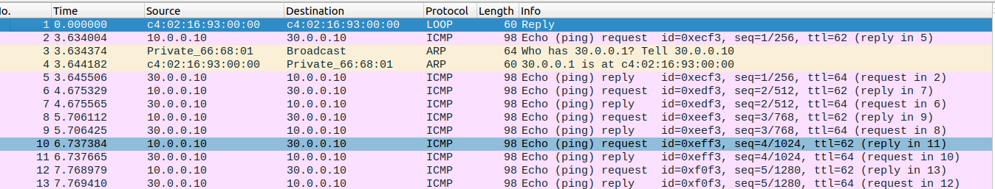
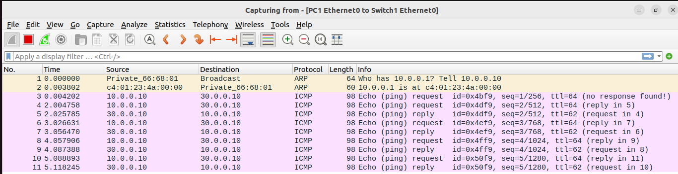
pc1 to r1
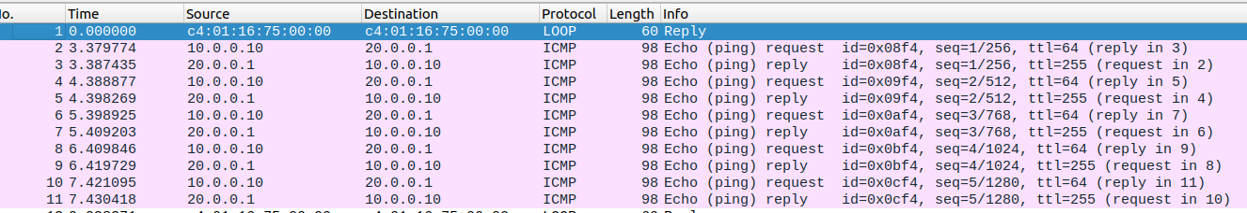
• Which packets, if any, are captured by Wireshark?
ARP & ICMP
• Do you observe any ARP packets? If so, what do they indicate?
ARP Packet is observed in the ping from pc1 to pc2. ARP broadcasts a request packet to find the destination IP address.
2. In the CSE department, two students sitting in two different labs want to establish a
connection and send the data. So, configure the below network topology as shown in Figure.
6.8 and check the connectivity by pinging from PC0 to PC2.

